Zaključni test – preverjanje: Celoletna snov s poudarkom na 4. in 5. enoti
šolsko leto 2018/2019

1. Zapiši dneve v tednu v angleščini (vsaka črtica predstavlja eno črko).
M __ __ __ __ __ W __ __ __ __ __ __ __ __ S __ __ __ __ __ T __ __ __ __ __ __ __

2. Poimenuj 5 šolskih potrebščin v angleščini. ______________________________________________
3. Napiši angleške besede za barve.

bela: _________
oranžna:__________
rumena: __________
vijolična_________

4. Zapiši zaimke v angleščini.

jaz = ______
on = ______
vidva = _______
oni = _______

5. Vstavi AM, IS ali ARE v trdilni ali nikalni obliki, tako da bodo stavki držali.

I __________ 12 years old and my name ___________ Jan. I _____________ a girl.
My parents _____________ cool. Their names ______________ Mojca and Toni.
My English teacher ____________ Mojca Miklavčič. My class teacher ________________ Marta Nardin.
My first lesson on Friday _____________ maths. Maths _____________ difficult.
Today ______________ Tuesday. I ___________ a student at OŠ Polje.

6. Zapiši številke z besedo:

12: ______________________________________
24: ______________________________________
45: ______________________________________
92: ______________________________________
13: ______________________________________
15: ______________________________________

7. Poveži nasprotja.

1 brother
2 fair
3 difficult
4 modern
A easy
B sister
C old
D dark
Rešitve 1 _____
2 _____
3 _____
4 _____

8. Na črte napiši pravo vprašalnico iz okvirčka.
How often When Why Where What

1 ‘_____________ does Tom do after school’ ‘He goes to the basketball practice’
2 ‘_____________ is your birthday?’ ‘It’s in June.’
3 ‘_____________ do you like science?’ ‘Because it is interesting.’
4 ‘_____________ does your mum play computer games?’ ‘Never.’
5 ‘_____________ are you from?’ ‘Poland.’
9. Napiši stavke s HAVE GOT. = trdilna oblika = nikalna oblika
1 he / an interesting hobby () _________________________________________________
2 they / a new car. () ________________________________________________________
3 you / a pet () ____________________________________________________________
- Becky / this DVD. () _______________________________________________________

10. Poveži športe oz. krožke.
1___ 2___ 3___ 4___ 5___
1 This sport is a team sport. a science
2 I’m into board games. b basketball
3 Usain Bolt is my favourite sportsperson. c athletics
4 I’m into difficult games. d chess
5 This sport isn’t easy, but it’s fun. e gymnastics
11. Spodnje stavke zapiši v nikalni in vprašalni obliki.
trdilna oblika | nikalna oblika | vprašalna oblika
You go to school every day.

She eats burek.

The boy studies art.

Your mum is a teacher.

12. Dopolni, kaj počnejo pridni učenci.
1 I don’t f__ __ __ __ __ my homework.
2 We don’t s__ __ __ __ in the classroom. We’re quiet.
3 We don’t u__ __ our phones in class.
4 He r__ __ __ __ __ his hand to speak in class.
5 We c__ __ __ to class on time.
13. Dopolni z nikalno obliko glagolov v oklepaju.
1 We _______________ football at school. (play)
2 They _______________ in the morning. (eat)
3 He _______________ to school. (walk)
4 I _______________ English lessons. (like)
5 Our school _______________ exams at the end of term. (have)

14. Prevedi v angleščino:
- Otroci so vedno veseli. __________________________________________________________________
- Mia včasih igra košarko. __________________________________________________________________
- Ti nikoli ne greš kolesarit. _______________________________________________________________________

15. Dopiši, kaj Tim dela popoldne.
In the afternoon he___________(do) his homework, ___________(read) a book and________________(play) basketball with his friends. He ____________(finish) his training at 4 _____________. He _________(come) home and they________(eat) dinner.In the evening his parents_________(go) out. He__________(study) for school and ____________(watch) TV.
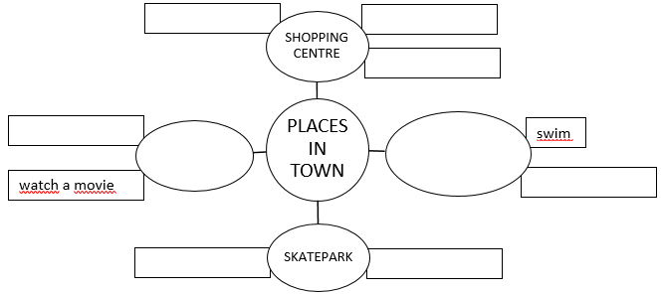
16. Dopolni miselni vzorec. Na vsako črto zapiši eno ali več besed. Besede naj se smiselno povezujejo.

