NAME: __________________________

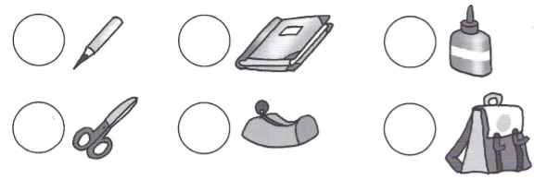1. SCHOOL 1 2 3 4 5 6



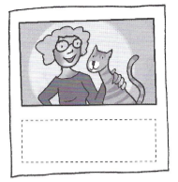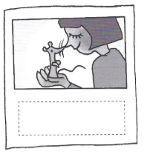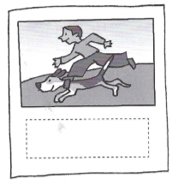2. TELEPHONE NUMBERS

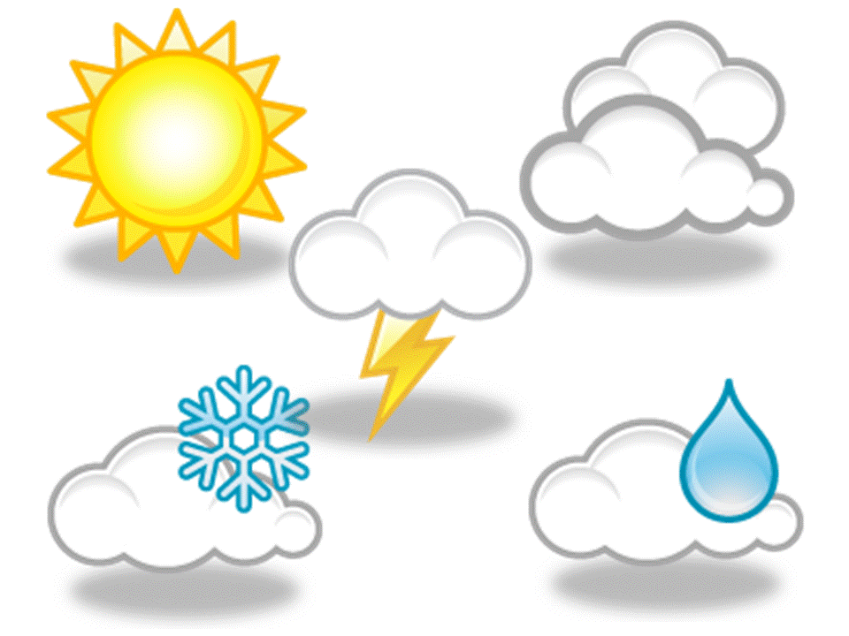3. WHAT'S THE WEATHER LIKE?

A) B)

4. COLOUR THE SHAPES

5. TOWN MOUSE AND COUNTRY MOUSE

