MY IDEAL HOUSE
My ideal house would have multiple floors, a big backyard & a garage, the backyard would also have a big pool.
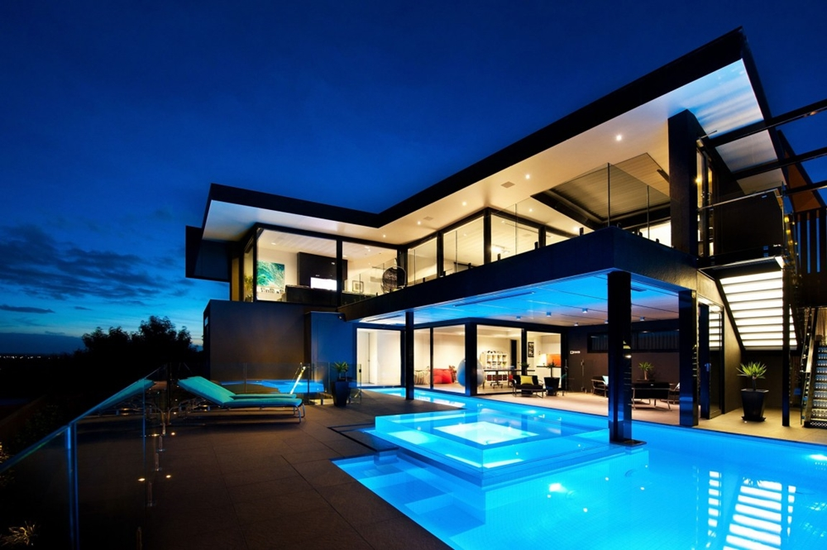
It would look something like that, but of course the pool in the back and a big backyard.
The house has a big balcony with a beautiful view of the city.
Now for the inside there would be a room for the guests, with some snacks and a television, the house would have 3-4 bedrooms with 2 bathrooms, a living room and the kitchen.
On the roof there would be a barbeque a big projector and a DJ room for the party’s.
The house would also have a button that would cover the whole house with metal if the zombie apocalypse happened.
That’s my ideal house hope you liked it and goodbye!.

