MY IDEAL HOME
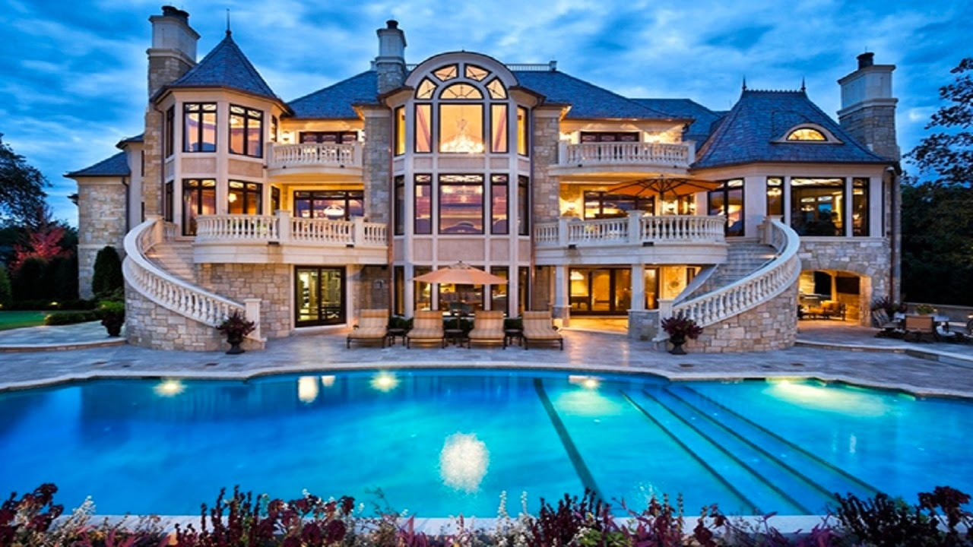

My ideal house looks like a castle it’s a really big house. It is in the small town with many people. My house has got a kitchen, dining and living room, 3 bedrooms and all bedrooms have a bathroom

