MY IDEAL HOME

My ideal home is in the United State of America. It is modern and very big and comfortable. It is surrounded by nature. It has a big swimming pool, a big garege, 3 or 4 patios. It has o lot of big glass windows. In the house there is some green plants.
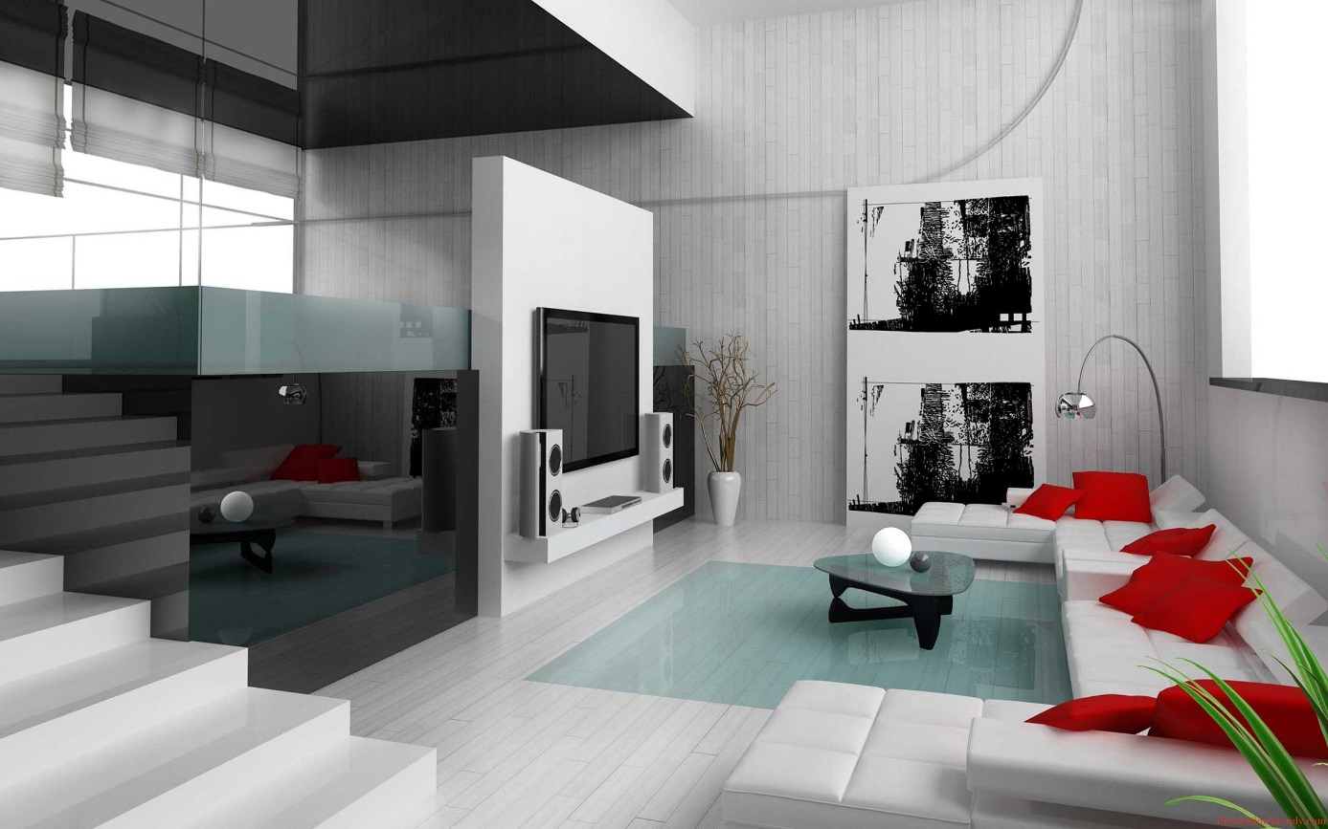
This is my second living room. It is very modern and big. There is a big TV, with the best speakers in the world, some modern paintings, a big white sofa with red pillows.

