MY IDEAL HOME
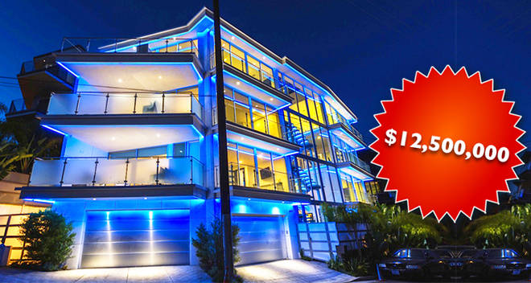
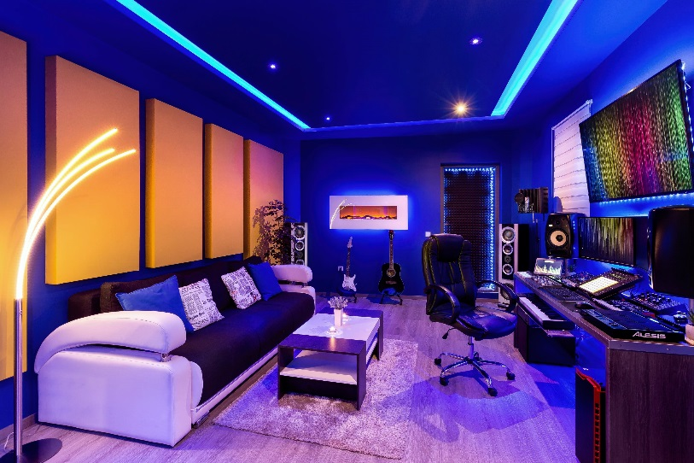
This is a picture of my ideal home. This is very modern house is located in Los Angeles. Is it got all kinds of rooms like gym, gaming rooms. This house has a lot of balcony and outside pool. From the balconies you can see view of a Los Angeles and beautiful view of sun sad. There is now one how write know, I don’t know what are they doing write know. My favorite room is gaming room there is a lot of candies and computers.

