MY IDEAL HOME
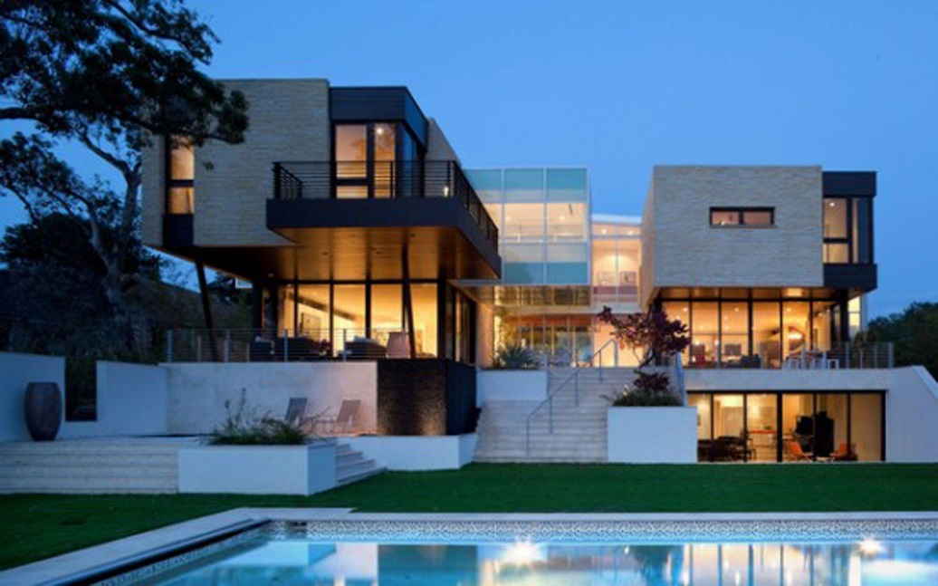
Here we are in my ideal home. It’s a modern and big house. It’s terraced house in Spain. It’s got a modern living room with the large fireplace, has a small and useful kitchen, It has very big windows and a large garden with a swimming pool and an outside kitchen where we roast meat. It’s have got a lot of rooms. There are two balconies with a table in the chairs where we hang out and fun. There is a big Jacuzzi and sauna. I live with my family and husband. We have two friendly and obedient dogs, one dog is a German shepherd and the other one is a husky .My favorite room is living room , because is very big, warm and because I'm having fun with my family and dogs. From my house I have a look at the beautiful place k has many street lamps.

