MY IDEAL HOME

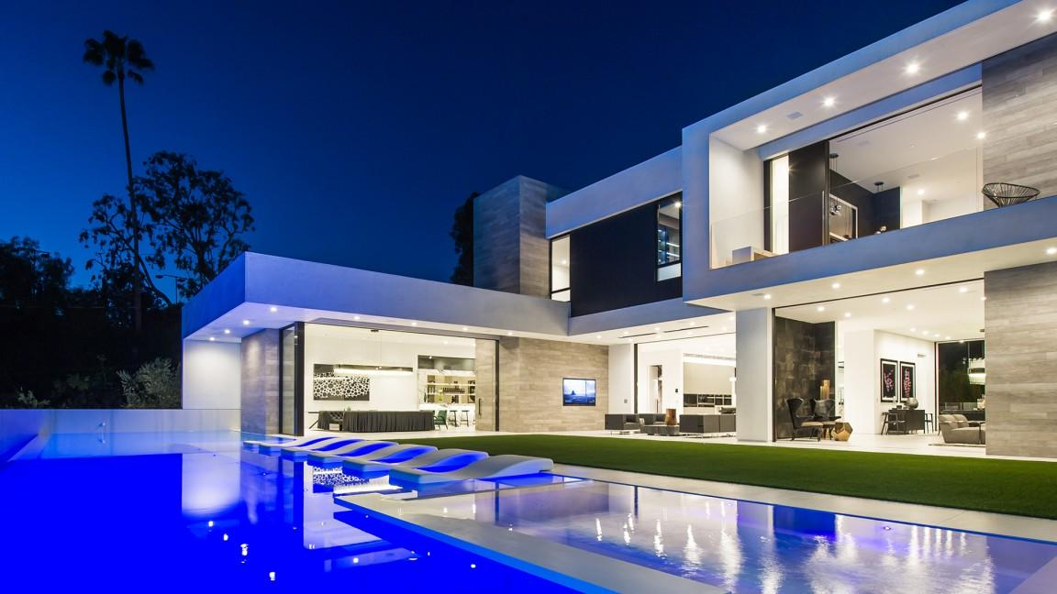

This is a picture of my ideal home. This is very modern house. My house have gym, gaming rooms, dining room, a lot of balcony and outside pool.

