MY IDEAL HOME

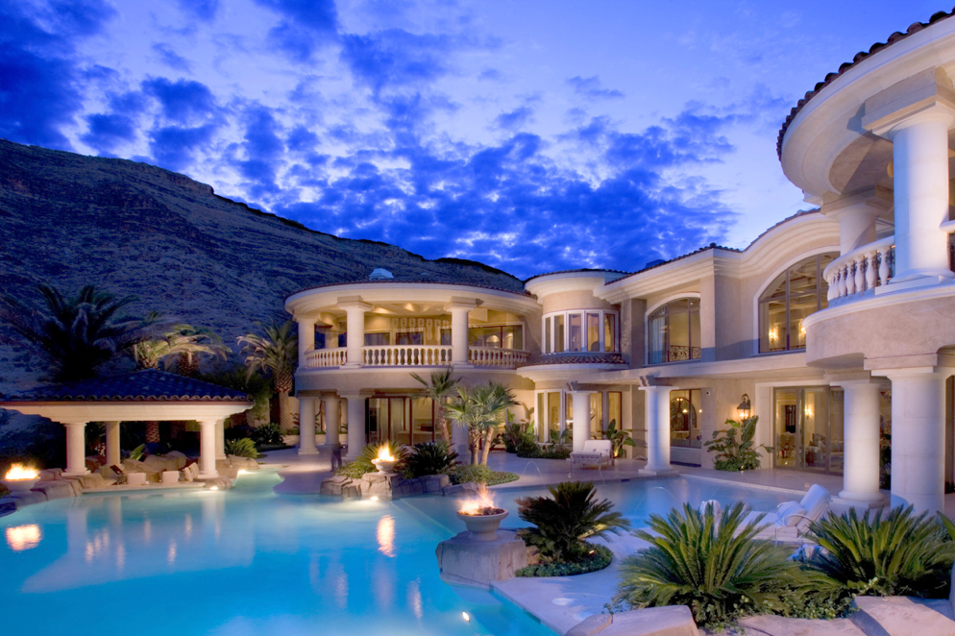
Is a big house in the small town. It’s got a kitchen, living room, 4 bedrooms with a bathrooms.

