MY IDEAL HOME
Here we are in my ideal home. My house is modern and big because I don't like old and small houses. My house is in on the beach in Florida. It's so big and all rooms are so big. These house has got a 4 bedrooms and 3 bathrooms because 2 of them is in the 2 bedrooms and one is in the hallway. There is also a big garden and big 4 balconies on the second floor. In my house is a cinema. It is so big and comfortable. The view is amazing. You can see only sea and it's amazing. And also I have got a big pool. We have got a three dogs. They are Pomeranians.

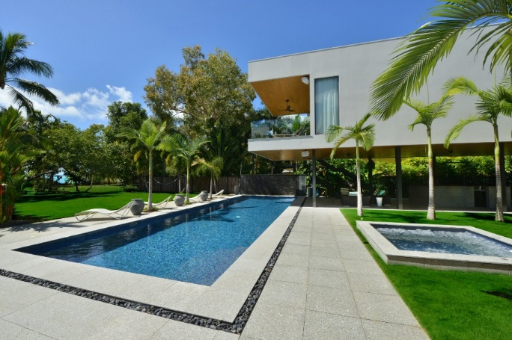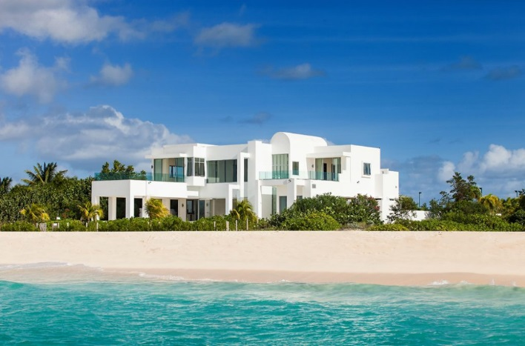
Pool view Sea view
Today we are all at home. It's Sunday. My mom is outside and she is talking on her phone. My dad is playing Xbox in the leaving room. I and my brother are in my bedroom and we are playing with Lego.
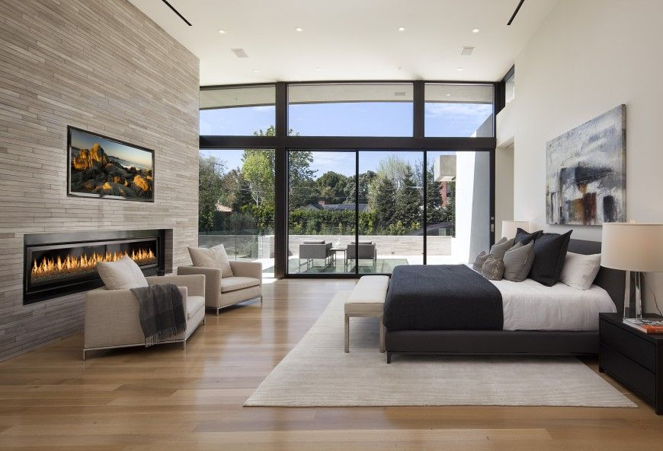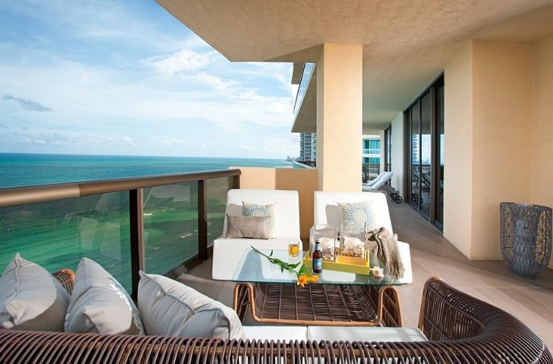
My bedroom My balcony
My favorite room is my bedroom because it has got everything like big bed, fireplace, big balcony… my room has got fireplace, big bed, night table, backrests, balcony, big TV, and a lot of modern paintings.

