MY IDEAL HOME
My ideal house would be a villa and lots of rooms to restoration and a pool view of the sea. And I have lots of balconies and my own football stadium.
I have big terrace. 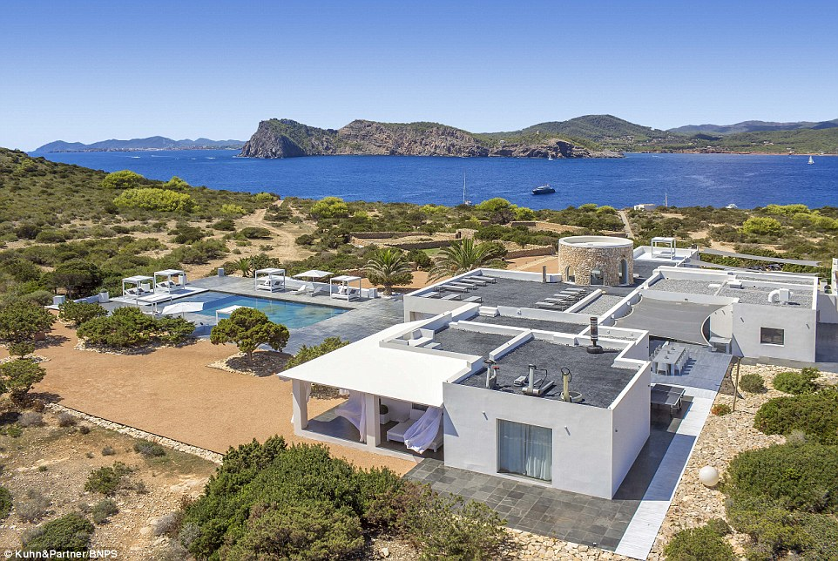

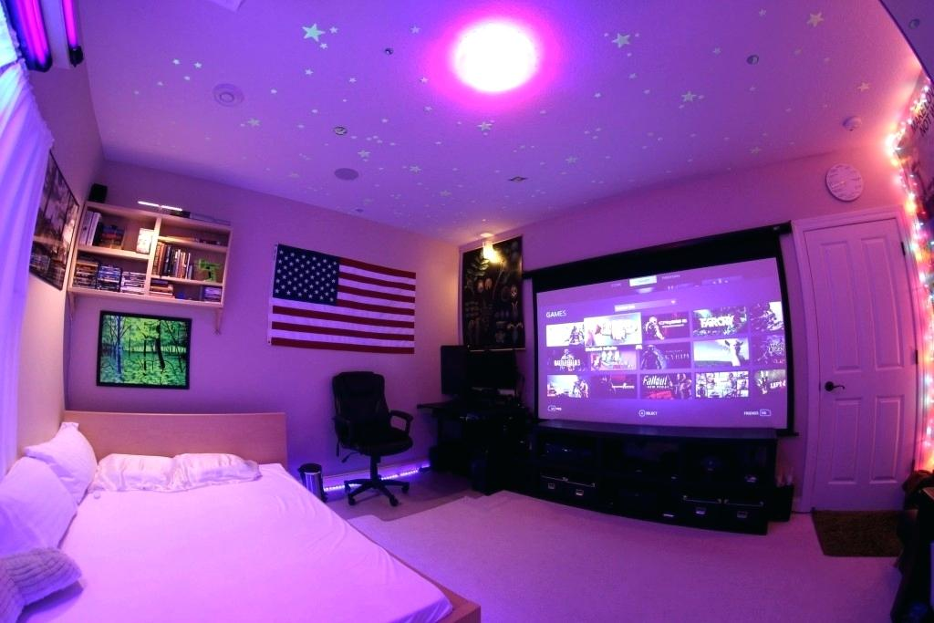
My ideal room it would be great with big tv and a good computer

