my ideal home
my ideal home is a big house with a football field.
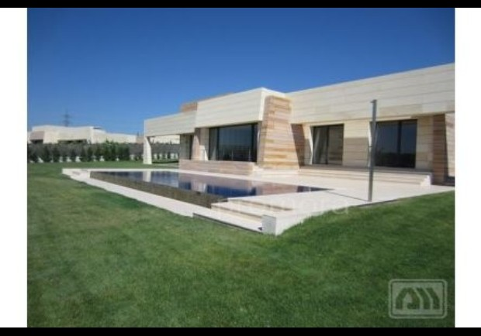

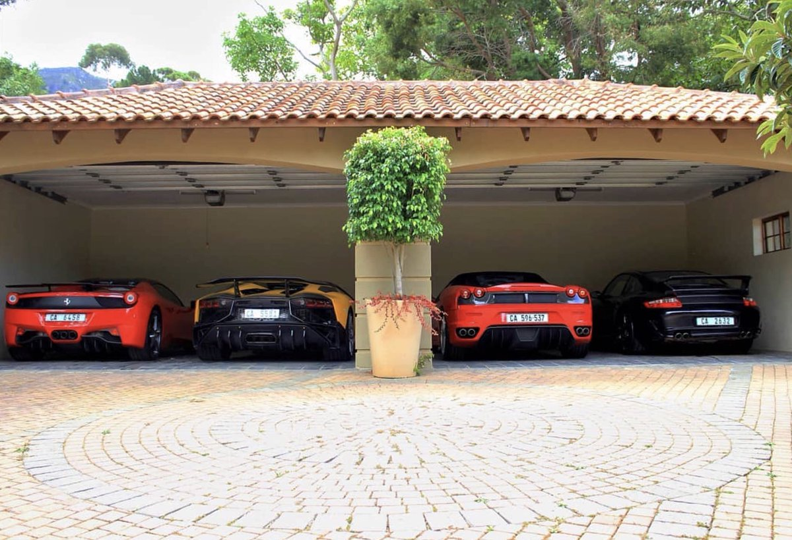
I also have a garage with expensive and sporty cars.
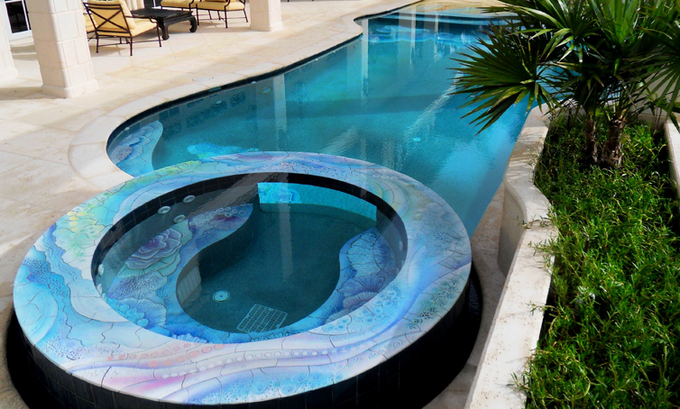
I have a swimming pool and a healthy pool is a Jacuzzi.

In the house I have two bedrooms one is for the guests and in the bedrooms I have a TV where I watch movies

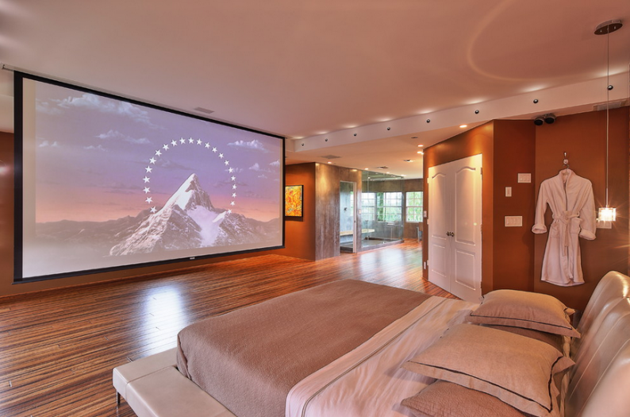

I also have two cute dogs

