My ideal home

My ideal home is weri big. In my home I have a lot of rooms. My favorite room is gaming room.
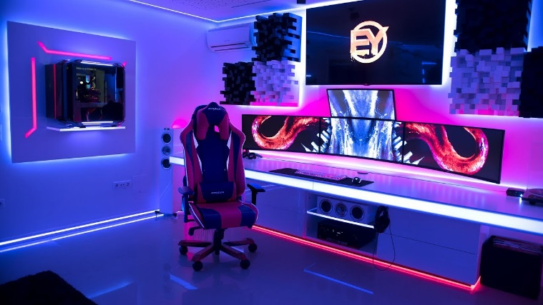
I also like my bed room because i like to sleep. I have a pool because. I also have a pool.
I have a lot of candy because I like to eat wen I play games. I have a big kitchen because I like to eat
Good food. I like football so I have a football stadium. I also like niece view so I have a big tower
And up there I have a big balcony.

